Aaditee Agrawal
22BCS11305
Fl_Iot 601 ‘A’
Ap experiment 9

- Number of Islands
class Solution {
public:
int numIslands(vector<vector<char>>& grid) {
constexpr int kDirs[4][2] = {{0, 1}, {1, 0}, {0, -1}, {-1, 0}};
const int m = grid.size();
const int n = grid[0].size();
int ans = 0;

auto bfs = [&](int r, int c) {
queue<pair<int, int>> q{{{r, c}}};
grid[r][c] = '2';
while (!q.empty()) {
const auto [i, j] = q.front();
q.pop();
for (const auto& [dx, dy] : kDirs) {
const int x = i + dx;
const int y = j + dy;
if (x < 0 || x == m || y < 0 || y == n)
continue;
if (grid[x][y] != '1')
continue;
q.emplace(x, y);
grid[x][y] = '2';
}
}
};

for (int i = 0; i < m; ++i)
for (int j = 0; j < n; ++j)
if (grid[i][j] == '1') {
bfs(i, j);
++ans;
}

return ans;
}
};
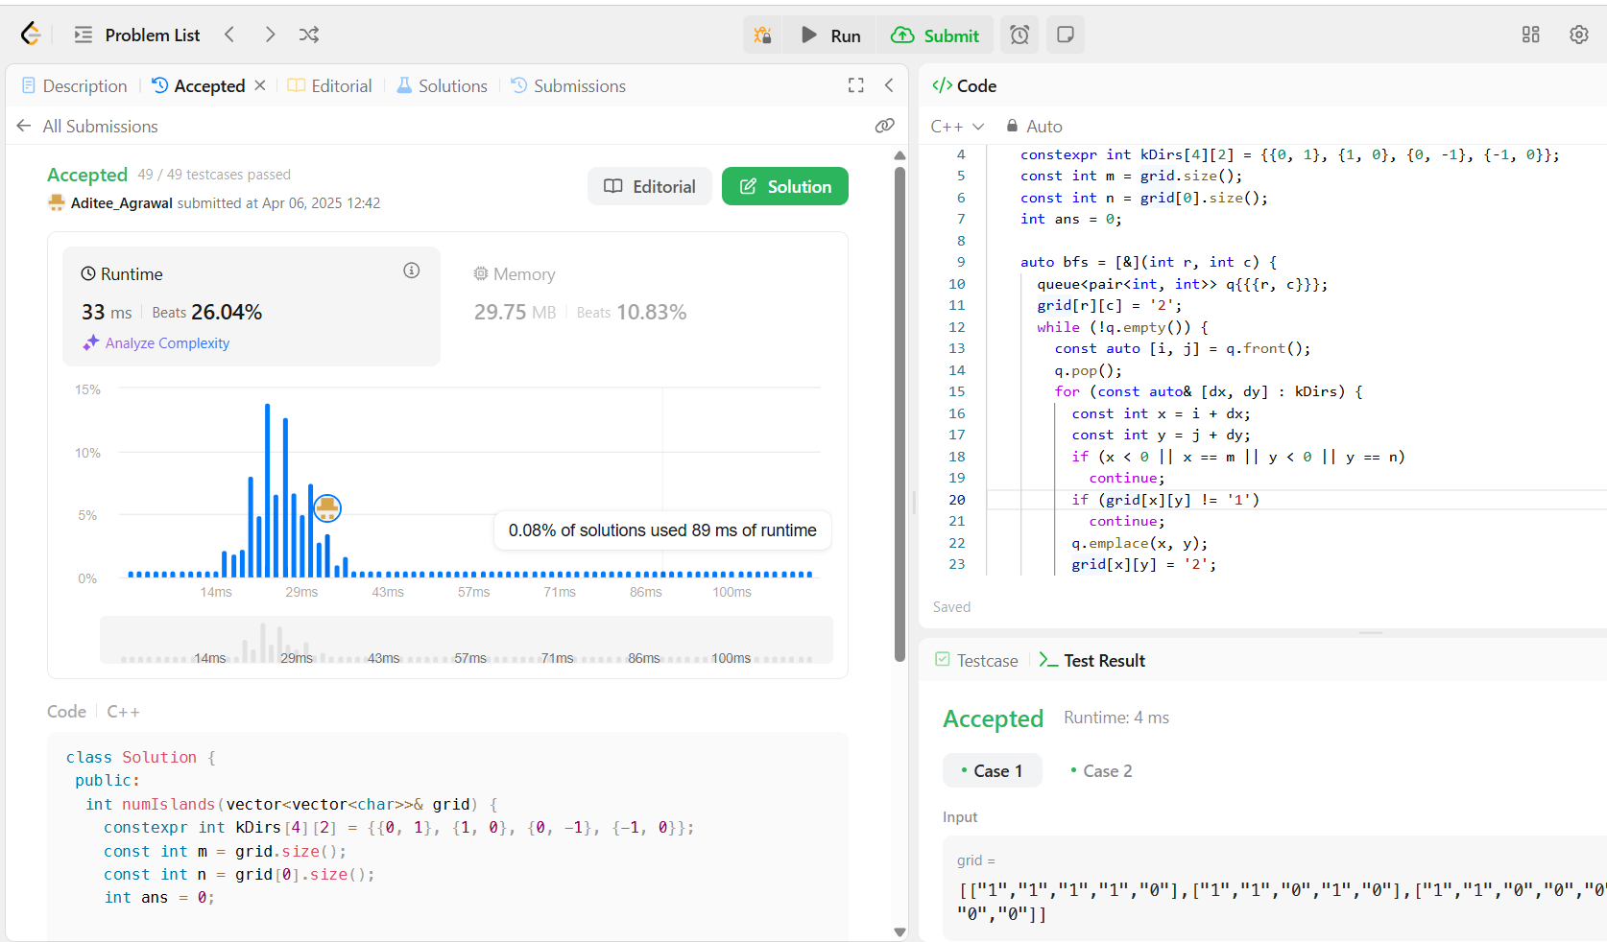

- Word Ladder
class Solution {
public:
int ladderLength(string beginWord, string endWord, vector<string>& wordList) {
unordered_set<string> wordSet(wordList.begin(), wordList.end());
if (!wordSet.contains(endWord))
return 0;

queue<string> q{{beginWord}};

for (int step = 1; !q.empty(); ++step)
for (int sz = q.size(); sz > 0; --sz) {
string word = q.front();
q.pop();
for (int i = 0; i < word.length(); ++i) {
const char cache = word[i];
for (char c = 'a'; c <= 'z'; ++c) {
word[i] = c;
if (word == endWord)
return step + 1;
if (wordSet.contains(word)) {
q.push(word);
wordSet.erase(word);
}
}
word[i] = cache;
}
}

return 0;
}
};
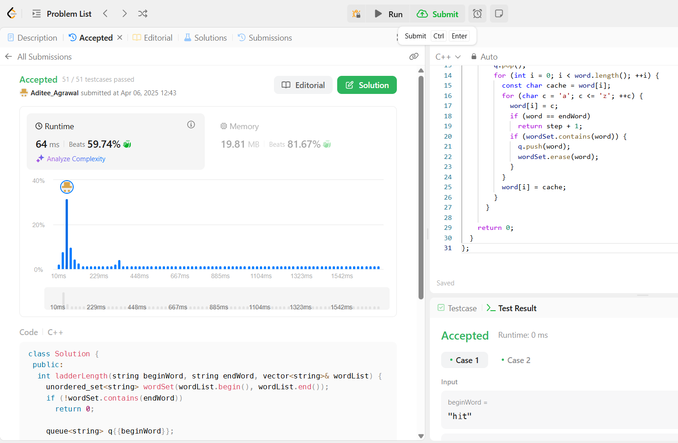

- Surrounded Regions
class Solution {
public:
void solve(vector<vector<char>>& board) {
if (board.empty())
return;
constexpr int kDirs[4][2] = {{0, 1}, {1, 0}, {0, -1}, {-1, 0}};
const int m = board.size();
const int n = board[0].size();

queue<pair<int, int>> q;

for (int i = 0; i < m; ++i)
for (int j = 0; j < n; ++j)
if (i * j == 0 || i == m - 1 || j == n - 1)
if (board[i][j] == 'O') {
q.emplace(i, j);
board[i][j] = '*';
}
while (!q.empty()) {
const auto [i, j] = q.front();
q.pop();
for (const auto& [dx, dy] : kDirs) {
const int x = i + dx;
const int y = j + dy;
if (x < 0 || x == m || y < 0 || y == n)
continue;
if (board[x][y] != 'O')
continue;
q.emplace(x, y);
board[x][y] = '*';
}
}

for (vector<char>& row : board)
for (char& c : row)
if (c == '*')
c = 'O';
else if (c == 'O')
c = 'X';
}
};
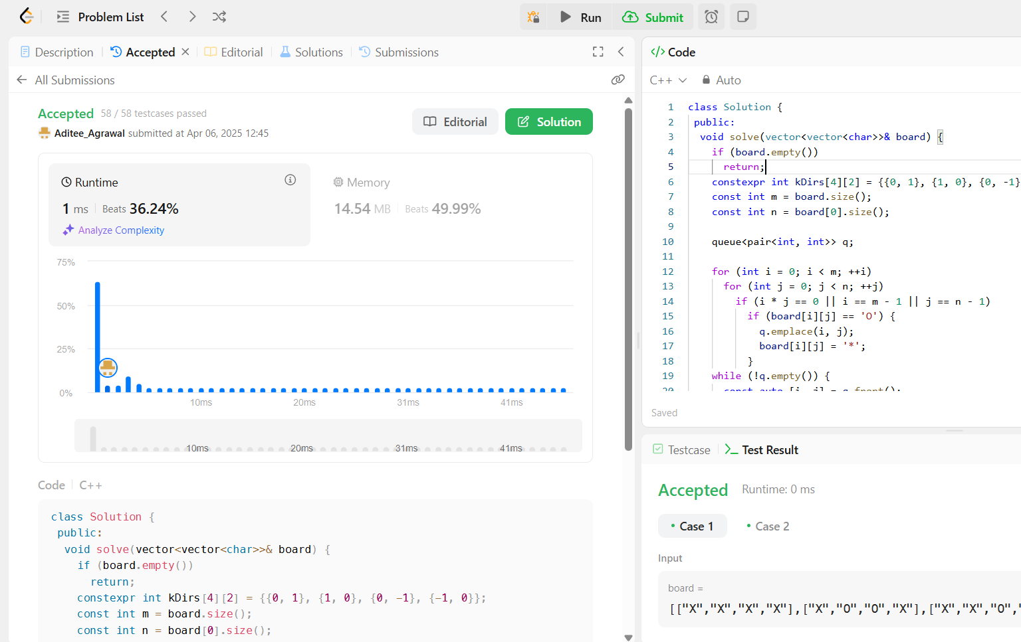
- Binary Tree Maximum Path Sum
class Solution {
public:
int maxPathSum(TreeNode* root) {
int ans = INT_MIN;
maxPathSumDownFrom(root, ans);
return ans;
}

private:
int maxPathSumDownFrom(TreeNode* root, int& ans) {
if (root == nullptr)
return 0;

const int l = max(0, maxPathSumDownFrom(root->left, ans));
const int r = max(0, maxPathSumDownFrom(root->right, ans));
ans = max(ans, root->val + l + r);
return root->val + max(l, r);
}
};
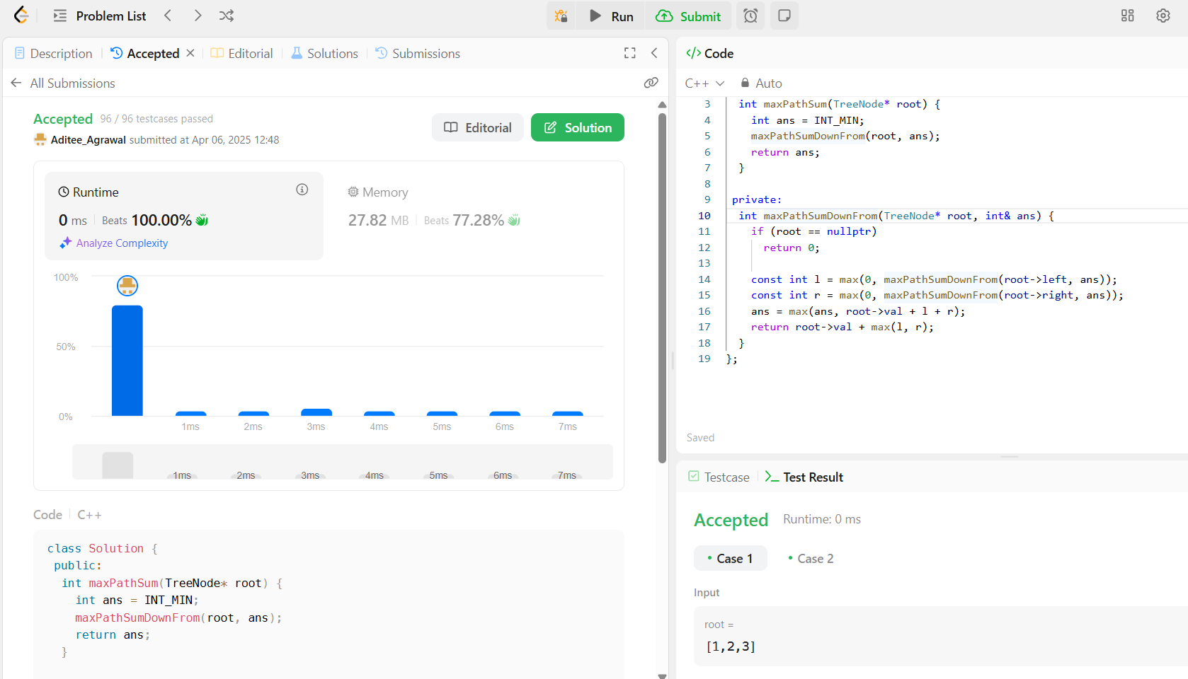

- Number of Provinces
class UnionFind {
public:
UnionFind(int n) : count(n), id(n), rank(n) {
iota(id.begin(), id.end(), 0);
}

void unionByRank(int u, int v) {
const int i = find(u);
const int j = find(v);
if (i == j)
return;
if (rank[i] < rank[j]) {
id[i] = j;
} else if (rank[i] > rank[j]) {
id[j] = i;
} else {
id[i] = j;
++rank[j];
}
--count;
}

int getCount() const {
return count;
}

private:
int count;
vector<int> id;
vector<int> rank;

int find(int u) {
return id[u] == u ? u : id[u] = find(id[u]);
}
};

class Solution {
public:
int findCircleNum(vector<vector<int>>& isConnected) {
const int n = isConnected.size();
UnionFind uf(n);

for (int i = 0; i < n; ++i)
for (int j = i; j < n; ++j)
if (isConnected[i][j] == 1)
uf.unionByRank(i, j);

return uf.getCount();
}
};
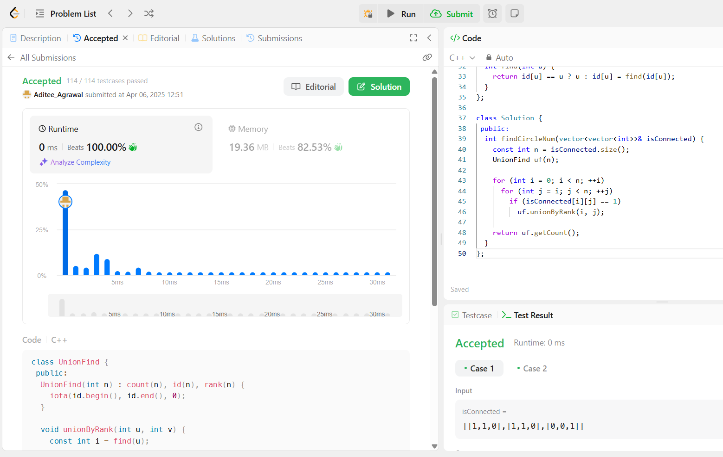

- Lowest Common Ancestor of a Binary Tree
class Solution {
public:
TreeNode* lowestCommonAncestor(TreeNode* root, TreeNode* p, TreeNode* q) {
if (root == nullptr || root == p || root == q)
return root;
TreeNode* left = lowestCommonAncestor(root->left, p, q);
TreeNode* right = lowestCommonAncestor(root->right, p, q);
if (left != nullptr && right != nullptr)
return root;
return left == nullptr ? right : left;
}
};
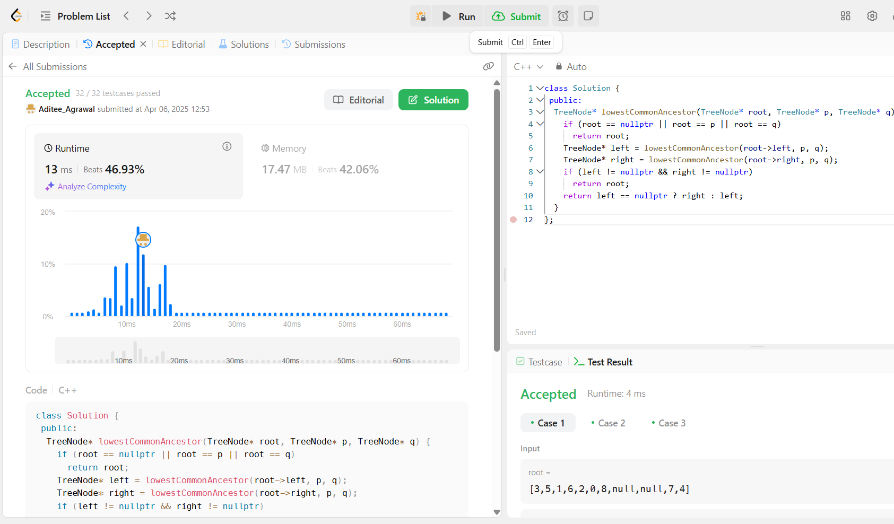

- Course Schedule
enum class State { kInit, kVisiting, kVisited };

class Solution {
public:
bool canFinish(int numCourses, vector<vector<int>>& prerequisites) {
vector<vector<int>> graph(numCourses);
vector<State> states(numCourses);

for (const vector<int>& prerequisite : prerequisites) {
const int u = prerequisite[1];
const int v = prerequisite[0];
graph[u].push_back(v);
}

for (int i = 0; i < numCourses; ++i)
if (hasCycle(graph, i, states))
return false;

return true;
}

private:
bool hasCycle(const vector<vector<int>>& graph, int u,
vector<State>& states) {
if (states[u] == State::kVisiting)
return true;
if (states[u] == State::kVisited)
return false;
states[u] = State::kVisiting;
for (const int v : graph[u])
if (hasCycle(graph, v, states))
return true;
states[u] = State::kVisited;
return false;
}
};
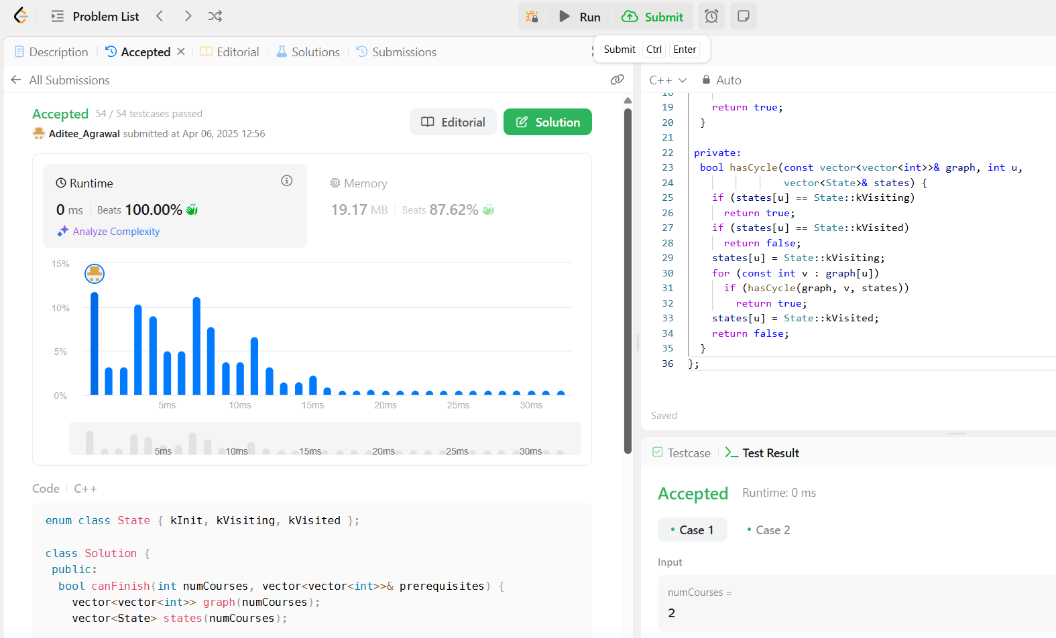

- Longest Increasing Path in a Matrix
class Solution {
public:
int longestIncreasingPath(vector<vector<int>>& matrix) {
const int m = matrix.size();
const int n = matrix[0].size();
int ans = 0;
vector<vector<int>> mem(m, vector<int>(n));

for (int i = 0; i < m; ++i)
for (int j = 0; j < n; ++j)
ans = max(ans, dfs(matrix, i, j, INT_MIN, mem));
return ans;
}
private:
int dfs(const vector<vector<int>>& matrix, int i, int j, int prev,
vector<vector<int>>& mem) {
if (i < 0 || i == matrix.size() || j < 0 || j == matrix[0].size())
return 0;
if (matrix[i][j] <= prev)
return 0;
int& ans = mem[i][j];
if (ans > 0)
return ans;

const int curr = matrix[i][j];
return ans = 1 + max({dfs(matrix, i + 1, j, curr, mem),
dfs(matrix, i - 1, j, curr, mem),
dfs(matrix, i, j + 1, curr, mem),
dfs(matrix, i, j - 1, curr, mem)});
}
};

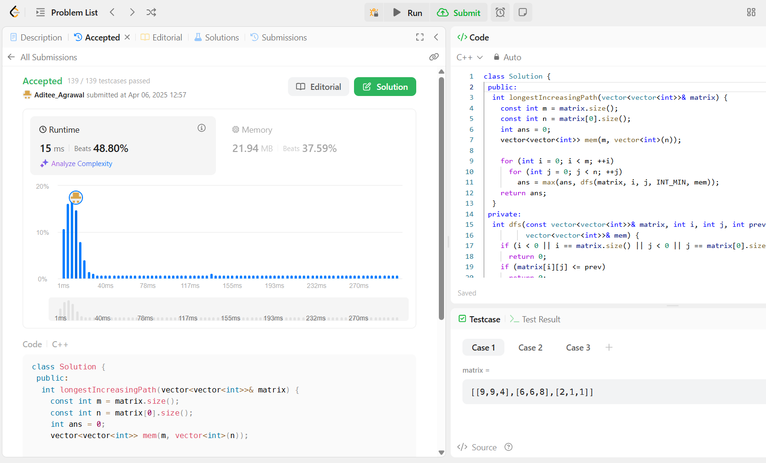

- Course Schedule II
enum class State { kInit, kVisiting, kVisited };

class Solution {
public:
vector<int> findOrder(int numCourses, vector<vector<int>>& prerequisites) {
vector<int> ans;
vector<vector<int>> graph(numCourses);
vector<State> states(numCourses);

for (const vector<int>& prerequisite : prerequisites) {
const int u = prerequisite[1];
const int v = prerequisite[0];
graph[u].push_back(v);
}

for (int i = 0; i < numCourses; ++i)
if (hasCycle(graph, i, states, ans))
return {};

ranges::reverse(ans);
return ans;
}

private:
bool hasCycle(const vector<vector<int>>& graph, int u, vector<State>& states,
vector<int>& ans) {
if (states[u] == State::kVisiting)
return true;
if (states[u] == State::kVisited)
return false;
states[u] = State::kVisiting;
for (const int v : graph[u])
if (hasCycle(graph, v, states, ans))
return true;
states[u] = State::kVisited;
ans.push_back(u);
return false;
}
};
